Mobiquity Interview code execution guide.

1. Code changes are present in zip file with name mobiquity-test.zip



1. Please unzip and extract to IDE for verification
2. As application is implemented in Spring boot frame work please run the “MobiquityTestApplication.java” to test the chages.
3. To test the changes related url’s are provided in postman collection.



Example:

1. Run the “MobiquityTestApplication.java”
2. To get all the Available ATM in JSON format please use below url.
   1. <http://localhost:8080/api/locator/atms>

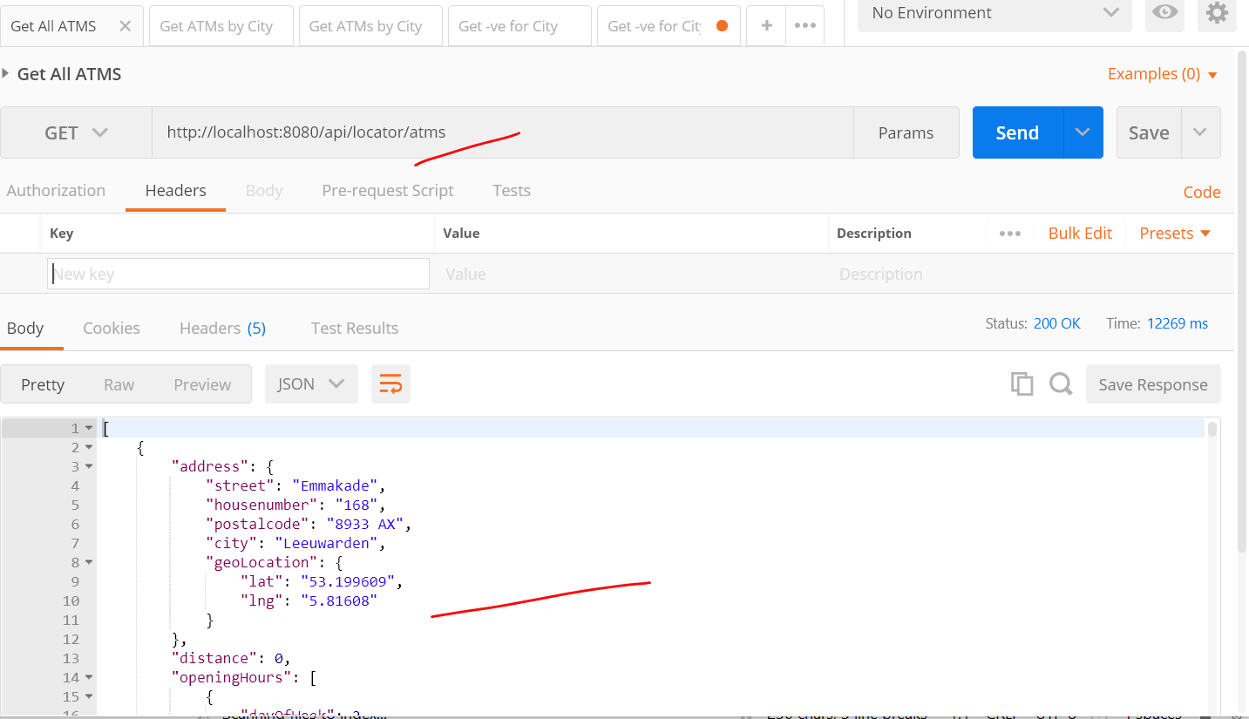

1. To get all the Available ATM by CITY in JSON format please use below url.
   1. <http://localhost:8080/api/locator/atms/Heemstede>
   2. <http://localhost:8080/api/locator/atms/Nijmegen>

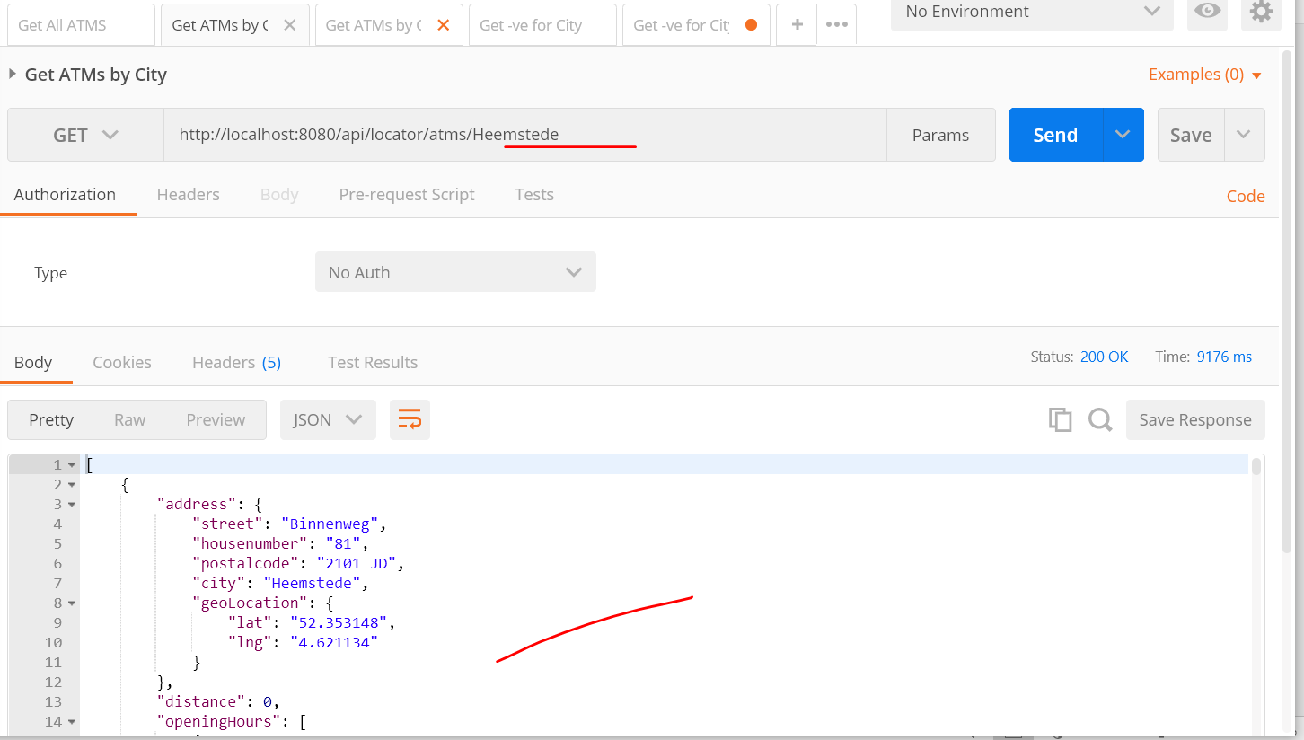

1. To test the negative test case related to the ATM search by City, please use below url.
   1. <http://localhost:8080/api/locator/atms/Heemstede1>

